***Under Armour Campaign plan to operate in Jordan***

***Campaign goal & target market***

Because under Armour is a new company in Jordan, the goal of the company’s advertising campaign is to spread awareness and try to generate sufficient knowledge of the brand and enhance the purchase process, and this will be done by posting advertisements in common places that the target customers exposed to. Our target customers are Demographics ages between 8-65, both genders male and female, location athletes all over the country. Psychographics are people who are interested in sports and healthy lifestyle, activities are football, basketball, iron players, and other clothing suitable for different types of sports.

***Media Selection***

For the street advertising campaign “outdoor advertising”, we will use the pedestrian bridge in Al Madinah AL Munawwarah street, and the message carried inside it is a one-way message and the message consist of the brand name and the logo of the company and two copies of the company shoes.

For the social media campaign, a logo of the brand will be published with the Jordan flag inside, to inform customers that the company is operating in Jordan, and the same advertising will be posted on the TV with the brand name and it will appear on the side of the TV (TV banner ad) and will take only 5 seconds.

And another types of media I will discuss it in the promotional mix.

***Tagline & and how did you come up with.***

The company’s slogan is I WILL, and it will be mentioned in the coupon sales promotion, social media ad but in a way that makes potential customers look for it.

***Positioning:***

***Product attributes:*** the company emphasizes the use of technology in its industry that make consumers feel better in performing exercises, and this feature puts it in a preferred position among its customers because it makes them feel that no one in the market (competitors) produces sportswear that suit them and understands their needs. ***Use or application:*** For every man or woman who strives to adhere to a healthy athletic lifestyle that helps them achieve the ideal weight that they seek to obtain by commitment. Long-lasting, comfortable and high-quality sport products, keep up with your high taste in wearing clothes.

***Price-quality relationship:*** high prices with a high quality sportswear.

***Product user:*** athletes, people who love sportswear, football and basketball players, and other fitness group.

***Cultural symbol:*** Under Armour is a symbol of speed, strength, and athleticism.

***Under Armour SWOT Analysis***

|  |
| --- |
| ***Strength****:*  **Innovation**: The Company has reduced its use of elastin, and the problem with elastin that it increases excessive sweating and needs longer drying time, wears out quickly, and is not recyclable. And replace it with new thread texturing techniques and polymer traits that eliminate the need for the elastin, which make the products lasts longer, and can be recyclable.  **Collaboration**: Because music is a major part when performing sports, the company has cooperated with JBL company to manufacture wireless headphones without wires, which made it distinct, easy to carry and comfortable (حجمها بحجم ابهم الاصبع), and on each earphone there is the logo of UA’s and the brand name of JBL company.  **Focus** on kid’s and women apparels.  **Brand recognition:** voted as being the 5th most valuable business brand in 2017.  **Developing of digital apps**: working-tacking app (I mention it before). |
| **Weaknesses:**  Limited presence in some countries such as Jordan and India. **/** Limited product range i.e. it has no multiple product categories. /High products prices. |
| **Opportunities**:  Focus more on corporate social responsibility. /Female market /E-commerce and media. /Increase in sports participation. |
| **Threats:**  Behavior change/ economic climate (Global recession) / Increase taxes. |

***Promotional Mix Strategy, Budgeting Strategy, Campaign Schedule & Campaign Duration***

***Marketing Strategy.***

***Sales Promotion:*** The company has issued coupons bearing the brand logo in the Jordanian flag colors, brand name, and their slogan with motivational phrase, and these coupon with price-off 30% will be distributed in our sponsorship places **Public Relations uses here** (fitness Vega and Golds Gym) + coupons will be obtained by their new and old customers, because these places their subscription prices correspond to the prices of our products.

***Objectives & Task Budget Method:*** because this type of promotion aims to influence the feelings of the customer, and once a sufficient percentage of sales is obtained from the issued coupons it will be withdrawn from the market. 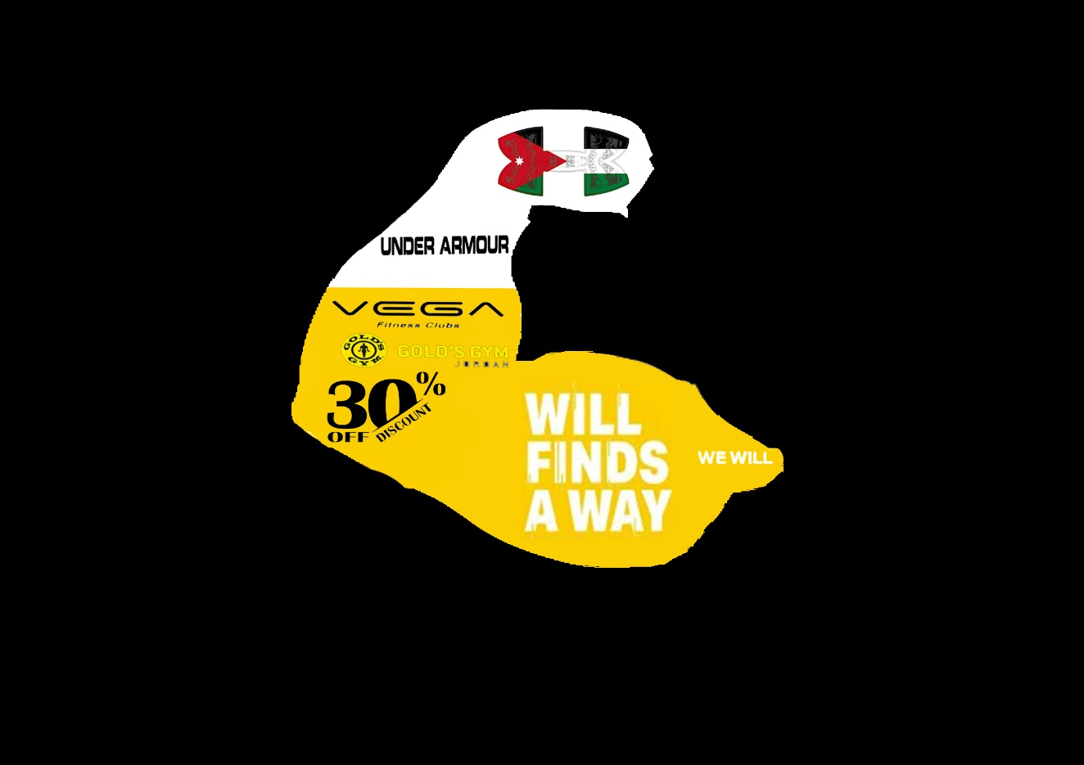

***Flighting Schedule:*** the coupons will be offered in the summer season because the number of customer’s subscriptions is at its peak.

***Campaign Duration:*** until the amount of coupons has run out or the goal of issuing them has been achieved.

***Advertising:*** There will be three types of ads (social media advertising, outdoor advertising and guerrilla marketing advertising).

***Social media advertising:*** The Company will participate in the Jordanian social media pages by putting up the trademark logo in the form of a post and inside it “logo” contains the Jordanian flag colors, the post will not contain the brand name and the slogan and here is the idea. In the content there is an activity that the customer must perform in order to obtain an opportunity that qualifies him/her to win a sports suit and shoes \*\***Contest promotion used here**\*. This activity will require the potential customer to post the post in his/her page and to comment in his/her content the name and slogan of the brand which will qualify him/her to win the reward. This activity will serve to duplicate “frequency” the brand’s name on Jordanian communications sites.

***Objectives & Task Budget Method:*** An unlimited number of people will be win until the company feels that the advertisement has succeeded in spreading sufficient awareness among the potential customers.

***Continues Campaign Schedule & Campaign Duration:*** until the advertising period end.

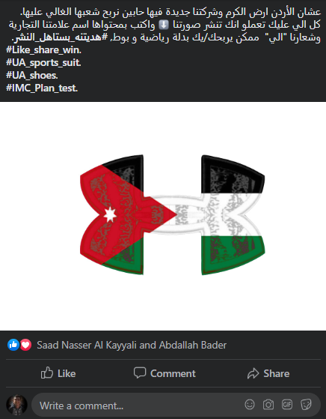

***Guerrilla marketing-Lifestyle marketing:***The advertising is target customers in the places where they do fitness exercises (lifestyle marketing), and the idea behind the guerrilla marketing is to put a large poster on the walls of the gyms that we have sponsor with them. And the poster image is a bodybuilder with muscles, world-famous, wearing sports clothes for our company. The logo of the company is colored with the Jordanian Shemagh colors found on the clothes that the bodybuilder wear.

***Meet The Competition Budget:*** Because the company is new in the Jordanian market, it is trying to take advantage from the weakness in competing brands advertisements, and gain market shares more quickly.

***Continues Campaign Schedule:*** The campaign will change with climate change, where the bodybuilder wears will be changed to suit the climate separation. i.e. (winter clothes in winter, in summer, summer clothes…),

***Duration of The Campaign:*** will last at least three months for each campaign.

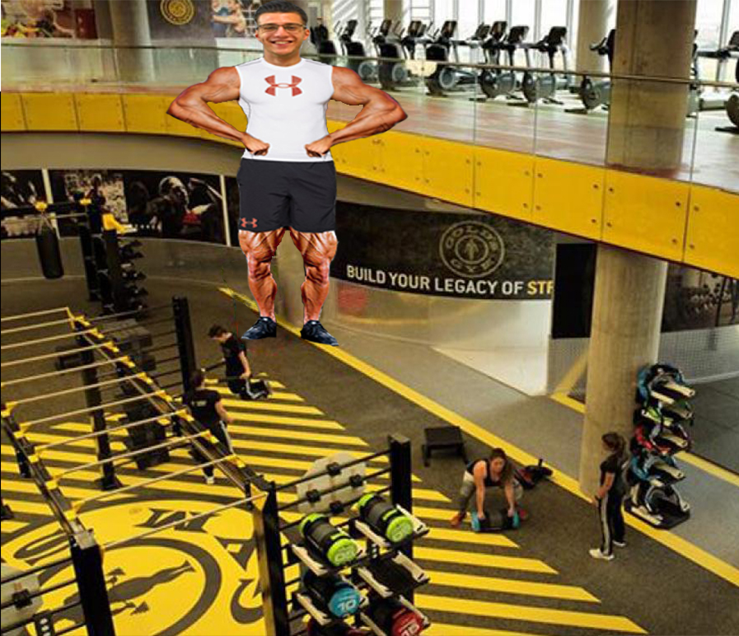

***Outdoor Advertising:*** street advertising will be placed on pedestrian bridges, so that it will attract the attention of people who walk or drive their cars, and this method will help spread awareness of the brand.

***Percentage of Sales Budget:*** The advertisement will be distributed initially on one bridge in AL-Madinah Al-Munawwarah Street, and if the advertisement achieves success it will be published on other bridges with different ideas.

***Flighting Schedule & Campaign Duration:*** The advertising will be published at the beginning of each climate season for a period of one month and fifteen days so that it does not become a Wear-out advertisement. And two weeks at the end of each season to inform customers about the end-of-season discount “advertising indicating discounts”.

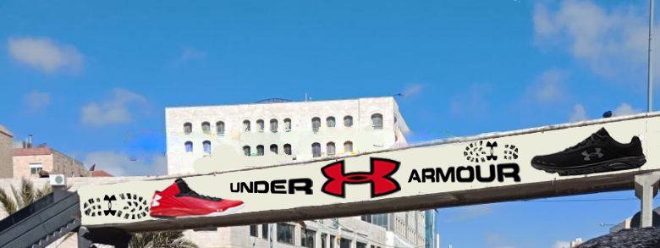

***Public Relation:*** The sponsorship will be held with the Jordanian basketball team because it is a team that does not have an official sponsor, and one of the other reasons that promoted UA’s to be the official sponsor to the team is that the Jordanian basketball is one of the teams that qualifies for the world championships every year, which will help the company to influence the Jordanian people minds in an indirect way to try our products; especially the people who love basketball.

***Objectives & Task Budget Method:*** A contract will be signed by the two parties (Jordanian basketball & Under Armour) for a one year sponsorship from Under Armour, and the contract contains that Under Armour only responsible for producing the players ‘clothes, shoes, and other player requirements for play. The percentage of basketball clothes sales will be calculated, and from the percentage the company will decide whether to renew the contract or not.

***Continues Campaign Schedule & Campaign Duration:*** throughout the year of the contract.

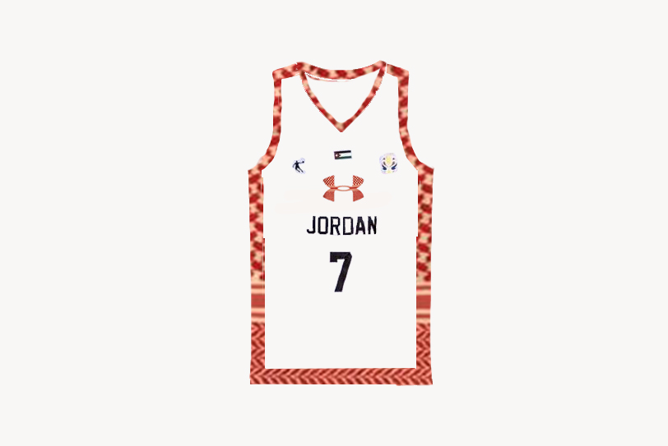

***Implementation, Evaluation & Control:***

Social media ad will be published initially to gain more knowledge of the brand, and the advertisement will be evaluated based on shares of the post by the users of the social media sites. The social media campaign will not depend on publishing the posts by social media users only, but the company will photograph the winners of the contest and publish it in its official social media sites on a weekly basis, which will reinforce more users to share the post to win the contest. 100 people will win weekly.

In the last periods of the social media campaign, the pedestrian bridge campaign will be published immediately, and the campaign will be evaluated based on the reactions of the Jordanian citizens, which will be collected through direct observations “people in the street, universities, malls…” and by publishing survey in social media sites contains questions about the campaign. The campaign will be controlled by changing the ad within it.

In the third stage, the guerrilla marketing and coupon sales promotion will be published on gyms, and the campaign will be evaluated based on the coupon utilization rate. The campaign will be controlled by changing the guerrilla marketing campaign and the sales promotion that will include new offers.

In the last stage, the public relation will be published to ensure coverage all the aspects of marketing activities, evaluation and control mentioned in public relation strategy.